**Experiment 7**

**AIM:**

Write a program to return absolute value of variable of type integer and float using function overloading.

**Theory:**

Function overloading is a feature in C++ where two or more functions can have the same name but different parameters. Function overloading can be considered as an example of polymorphism feature in C++.

When you call an overloaded function or operator, the compiler determines the most appropriate definition to use, by comparing the argument types you have used to call the function or operator with the parameter types specified in the definitions. The process of selecting the most appropriate overloaded function or operator is called overload resolution.

**Code:**

1. #include < iostream >
2. using namespace std;
3. int absolute_value(int x) {
4. return x > 0 ? x : -x;
5. }
6. float absolute_value(float x) {
7. return x > 0 ? x : -x;
8. }
9. int main() {
10. int x;
11. float y;
12. cin >> x >> y;
13. cout << absolute_value(x) << endl;
14. cout << absolute_value(y) << endl;
15. }

**Output:**

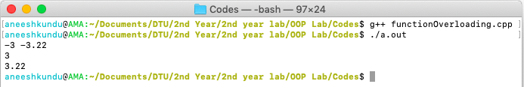

**Discussion:**

The absolute_value function is overloaded and can accept both integer and floating numbers, ansd return their corresponding absolute value.